The city of Mesa is facing difficulties with a kind of public transportation that they have been running since the last 2 years. It has a total of 10 stoppage points within the city to serve, which includes picking and dropping public to important market places, schools, college/university and other commercial locations. The distance between any to stoppage points be taken as |k-j| from stoppage point j. The total number of people who want to commute daily is given in the file P08_29.xlsx. The bus can make two stops, one during the onward journey and the other during the return journey and the people who want to take the bus or get down the bus can do so by walking/getting down to/at the closest stop available. The goal is to minimize the total distance people walk each day to take the bus or to walk back to their home once they are off the bus, keeping this in mind where should the bus stop locations be?
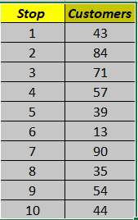
Discussion:
Our goal is to identify locations where we must set up bus stops with minimum total distance that people must travel to bus stop. So, our decision variable should be whether to build a bus stop or not. To calculate the total distance, we must create a calculated variable and create distance matrix $D_{ij}$
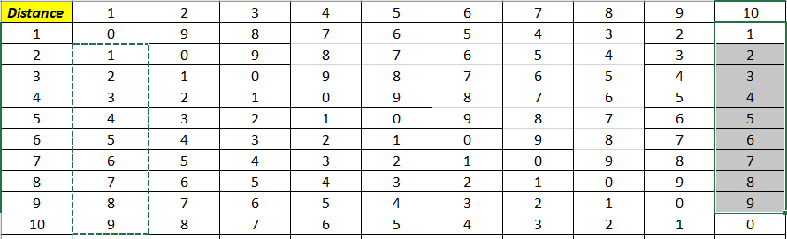
Mathematical Model:
$$i,j ∈1,2,3,4….n i-index for two locations$$
$$V_{i }:Number of customers that board at busstop i$$
$$e_{ij }:Whether location i is assigned to busstop j$$

Decision Variables:
$$z_{j}-decision to pick the location j as busstop or not$$
Calculated Variables:
$$D_{ij}-Distance from busstop i to j$$

Objective:
Minimize total distance $\sum_{i,j=1}^{9}{{(V}_{i}* e_{ij}*D_{ij})}$
Constraints:

$z_{j}$ $∈\left\{0,1\right\}$ ; {Binary Constraint}
$$\sum_{i=1}^{9}{e_{ij} ≤n* z_{j}; j ∈\{1,2,3…n\}}\sum_{j=1}^{9}{e_{ij} ≥1; j ∈\{1,2,3…n\}}$$ At least one bus stop to be assigned to each location
$\sum_{i=1}^{9}{z_{j} ≤2 ; }$Number of bus stops constriant

